Henkel
Functional Design Specification
SampleManager

Document Reference | xxxx-FDS-SAMPLEMANAGER-001
Version | 1.0
Last updated by | Zhenjuan.Zhang
Template Version | 1.0-0
Date | 15 July 2024
Status | Draft

chuxiaDocument Signoff
Name | Position | Company | Signature | Date

Table of Contents
Contents
1 Table of Contents 3
2 Introduction 5
2.1 This Document 5
2.1.1 Document overview 5
2.1.2 Disclaimer 5
2.1.3 Purpose 5
2.1.4 Scope 5
2.2 Synopsis 5
2.3 Definitions 5
2.4 References 6
3 Project Brief 7
3.1 Project Overview 7
3.1.1 Project detail 7
3.2 Functional Requirements 7
3.2.1 Sample Management 7
3.2.2 Shift Management 55
3.2.3 Master Data 63

Version Management
Version | Description | Name | Date
1.0 | Created | Zhenjuan.Zhang | 17 July 2024

Introduction

This Document

Document overview
This document describes the system functionality covered in the Henkel QCLad System Phase A RTM User Requirements Analysis Report.

Disclaimer
The screenshots used below are screenshots generated during the system standard functions or system configuration, as well as customer sample screenshots, the final design may be different from the screenshots in the document, and the data on the screenshots is not the real data of the system, only for reference.

Purpose
This document is used to provide a detailed description of the functionality of the SampleManager system, identifying a description of the system functionality that meets the user's business needs as specified in the User Requirements Analysis Report.

Scope
- Document the functional specifications of the laboratory management system based on the requirements described in the User Requirements Analysis Report.
- Determine the implementation of functionality in the system based on the needs described in the user needs analysis report

Synopsis
The core application functionality of the QCLad system is the laboratory sample process management functionality, including sample management, SAP interface, task scheduling, master data, reporting, architecture and security.;

Definitions
The following abbreviations and definitions are assumed throughout this document.
Term/  Abbreviation | Meaning | Description
FS | Function Specification | This Document
RMB | Right Mouse Button | Using RMB various Sample Manager options can be displayed
QCLAD | SampleManager | Software Name

References
The following references are made in this document.
Ref. No. | Reference | Description

Project Brief

Project Overview

Project detail
Implementation of SampleManager QCLad will streamline Sample Management, Reports, Dashboards, Instrument and Equipment management, Instrument interfacing and External application integration together with the associated data acquisition across Henkel’s labs.

Functional Requirements

Sample Management

Workflow

Business Scenarios
Generally, in QCLad system, the creation of a sample workflow is based on the creation of a sample lifecycle. According to the process of Henkel, we establish the sample lifecycle workflow, and the user can manually run the workflow and log in the sample as needed, in addition, the workflow can be automatically selected to create the sample by utilizing the SAP interface.

RTM Mapping

URS Ref. | Requirement | Type
4.1.5.1.1 | System shall be able to manage Standard RM test for Incoming workflow. （Standard RM） | Configuration
4.1.5.1.2 | System shall be able to manage Standard in process testing for semi finished and finished goods workflow. （without MES) | Configuration
4.1.5.1.3 | System shall be able to manage Standard finished goods outgoing test workflow. | Configuration
4.1.5.1.10 | System shall be able to manage Test for SCMS/NCMR /CCMS investigation workflow. | Configuration

Function Design
According to user requirements, we have created a QCLad Main Workflow as shown below, based on which different sample workflows can be created for different sample types, QCLad will utilize the standard functionalities and a level of configurations to meet such requirements.

Based on user requirements we create four workflows in Phase A as below:
Workflow1: IQC (Standard RM)
According to user requirements, IQC sample workflow is adapt to main workflow, therefore according main workflow system can create IQC(Standard RM) workflow as shown below.
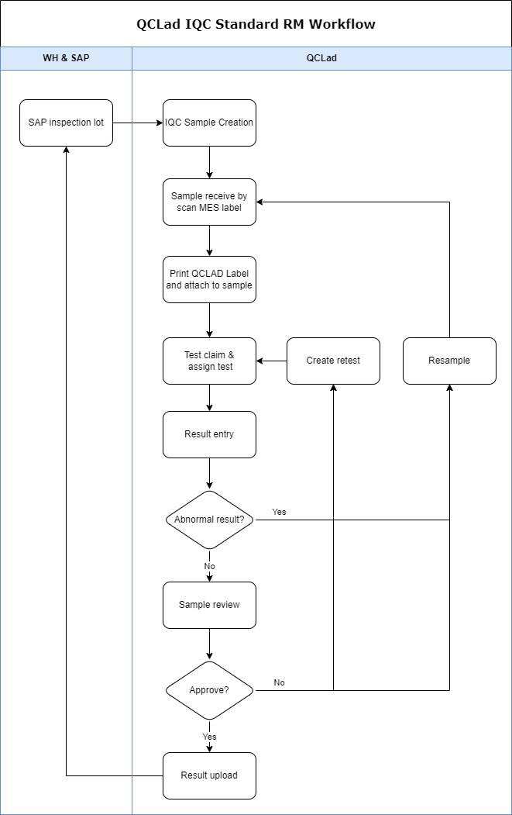

Workflow2: IPQC (without MES）
According to user requirements, IPQC sample workflow is adapt to main workflow, therefore according main workflow system can create IPQC(without MES) workflow as shown below..
Note: Function of IPQC last phase results copy to OQC initial sample results, finial solution is determined to display “copy result” button based on static data IDH that maintains in LIMS. Since it does not affect the IPQC workflow, it will not be described in detail here.
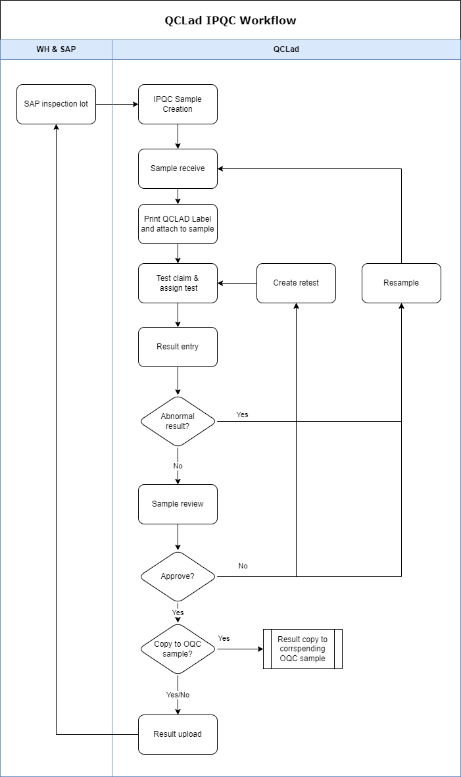
Workflow3: OQC
According to user requirements, for the OQC workflow, we need to add the function of copying IPQC last phase result to OQC as initial sample result, therefore based on main workflow, OQC add some workflow as shown below.
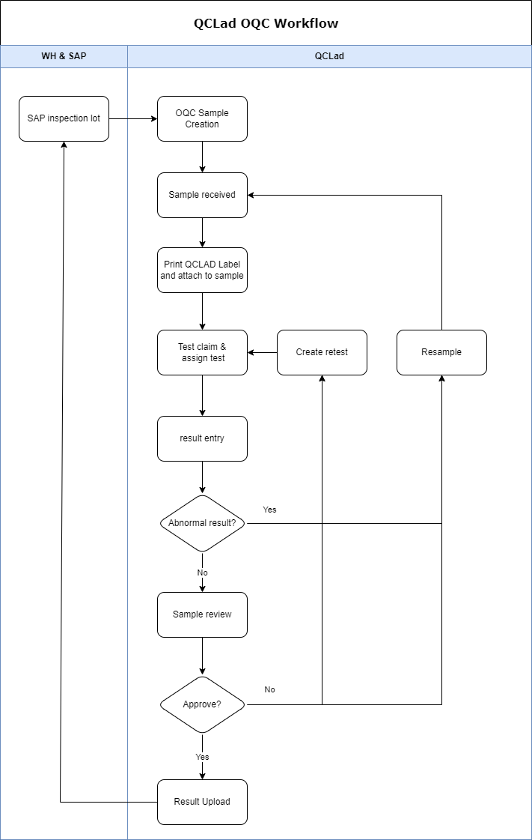

Workflow4: Non-standard Testing
According to user requirements, for Non-standard testing workflow, due to external requestor need to raise sample testing via email, finial solution is determined to edit in the excel of the email attachment, therefore Non-standard testing workflow as shown below to meet requirements. QCLad supports to add master data of MLP (analysis and specifications) that are sync from SAP insepction plan.
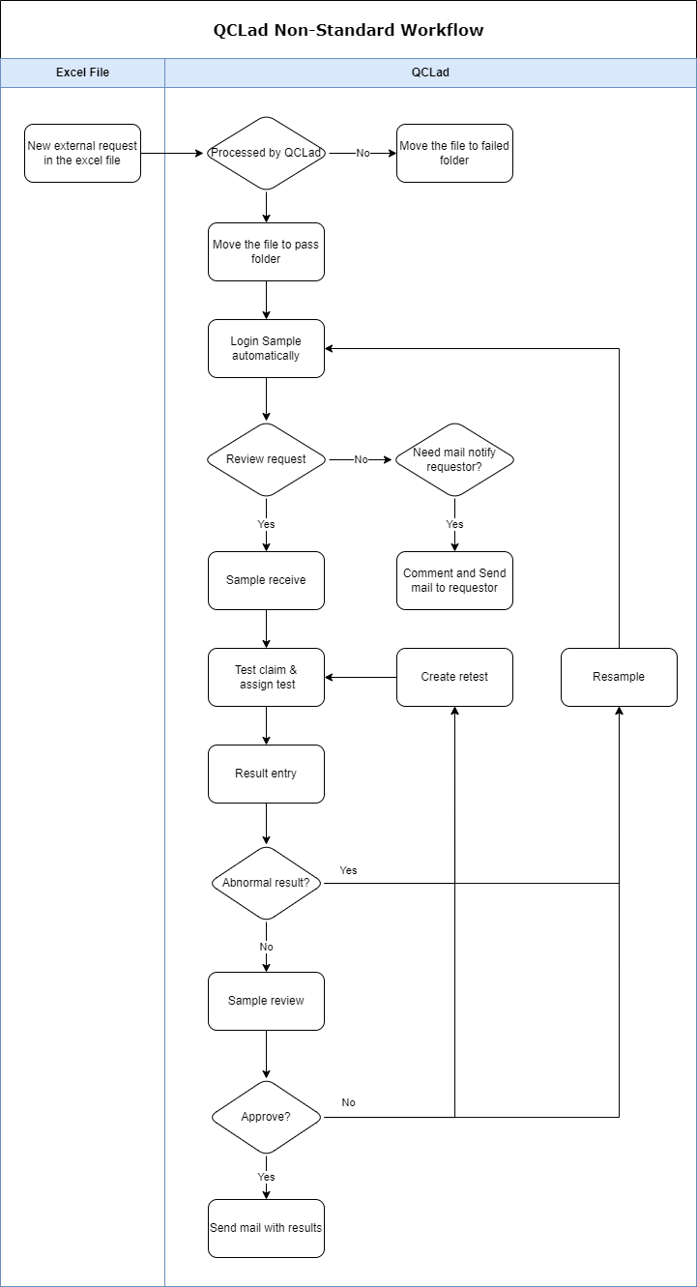

Sample Login

Business Scenarios
Generally, LIMS should allow user to manually log in different inspection type of samples. And for different inspection type, user can dynamically maintain the sample inspection request template, as of sample entity template in LIMS and its workflow respectively. And user can manually run the workflow and log in the sample as needed.

RTM Mapping
URS Ref. | Requirement | Type
4.1.1.1.1 | System shall be able to login samples using configurable templates | Configuration
4.1.1.1.3 | System shall be able to create samples manually for standard testing. | Configuration
4.1.1.1.4 | System shall be able to create samples manually for non-standard testing. | Configuration
4.1.1.3.1 | System shall assign a unique sample ID to each sample logged in. | Configuration
4.1.1.6.1 | System shall be able to define configurable attributes for a sample which can be modified. | Standard
4.1.1.7.1 | System shall be able to allow the definition of sample types and test schedule. | Standard
4.1.1.7.3 | System shall be able to log in predefined batches of samples at one time in accordance with a defined sampling plan. | Configuration
4.1.1.8.1 | System shall be able to log in either single or multiple samples from the same batch. | Standard
4.1.1.10.1 | System shall be able to log in non routine samples. | Standard
4.1.1.10.2 | System shall allow specific user to select specifications and test methods for non routine samples. | Standard
4.1.1.15.1 | System shall be able to allow user to enter comments at Sample log-in. | Configuration

Function Design
Requirements Description：
Users can create samples and tests with unique ID for routine and non-routine testing through configurable templates, and users can add comments while sample login manually. (Based on RTM as above)
Design Overviews：
- Table change
Add new table
i: table_plant
ii: table_ work center
Add new fields in sample table
i: idh, text
ii: plant code, link to table plant
iii: storage condition, text
iv: activity no, real
v: work center, link to table work center
vi: mfg date, date
vii: expired date, date
viii: test item, text
ix: requestor, text
x: requestor address, text
- Entity templates
Add four configurable entity templates for four different workflows in Phase A.
i: IQC entity templates, description: For Standard RM
ii: IPQC entity templates, description: For without MES
iii: OQC entity templates
iv: Non-standard testing entity templates
- Workflows
Add four sample login workflows for creating new samples and tests.
i: IQC workflow, description: For Standard RM
ii: IPQC workflow, description: For without MES
iii: OQC workflow
iv: Non-standard testing workflow
- Cabinet and folders
Maintain cabinet and folder for sample management.
i: add sample management cabinet
ii: add sample login folder
iii: add new sample pending receiving folder
- Functional logic
While the sample login successfully, the sample automatically created and automatically record the current server time and operator：
i: The sample status update as “unavailable”
ii: The operator is recorded as “created by”
iii: The sample created exist in sample pending receiving folder.
Labels can be printed manually in sample pending receiving folder.

Function Entrance：
Sample Management Cabinet àSample Login FolderàRight click menu “Run Workflow”
User can start manual login samples by right click ‘run workflow’ button on specific workflows. Sample login interface will be different according to requirements based on different sample type.
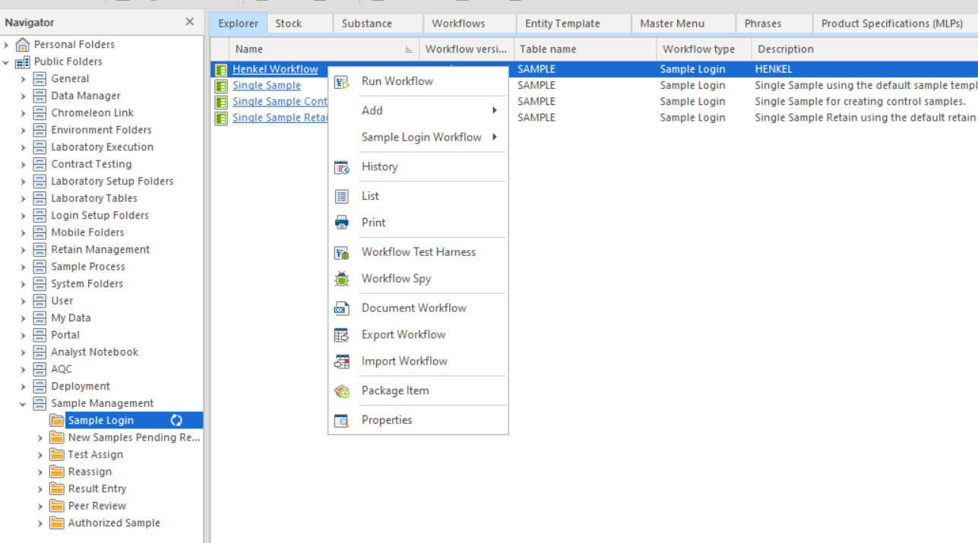
User Interface Design Reference：
According 3.2.1.1 and requirements, LIMS will create four configurable entity templates for four workflows in Phase A. Detail properties and user interface reference as below:
Note: According to the requirements description, this part of the content for creating samples manually, the data fields corresponding of samples pulled from SAP will be detailed in Part xx.xx.xx, see the Interface module for more information, so will not go into the details of the fields and SAP associated here.
Entity template 1: for IQC (Standard RM) workflow
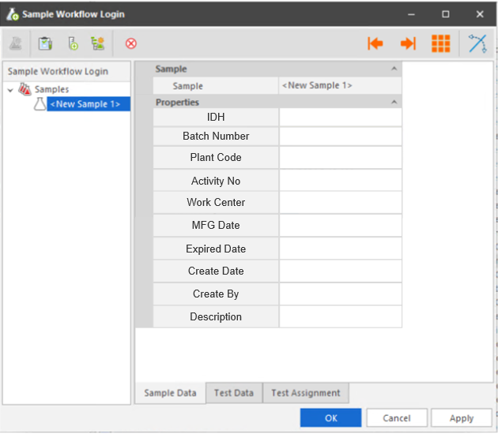
Properties in entity template clarification in LIMS:
No. | Properties | Type | Prompt Type | Description
1 | IDH | Numeric | Mandatory | Links to MLP table
2 | Batch | Text | Mandatory | Batch id
3 | Plant code | Text | Optional | Links to Plant table
4 | Activity No | Numeric | Optional | Activity number
5 | Work Center | Text | Optional | Links to Work centre table
6 | Create Date | Date | Optional | Current date, modifiable.
7 | Create By | Operator | Optional | Current operator
8 | Description | Text | Optional | Descriptiom
9 | Sample Type | Default | Hidden | IQC；sample type workflow is automatically assigned by lims
10 | MFG Date | Date | Optional | Manufacture date
11 | Expired Date | Date | Optional | Expiration date
14 | Test Schedule | Default | Hidden

Entity template 2: for IPQC (without MES) workflow
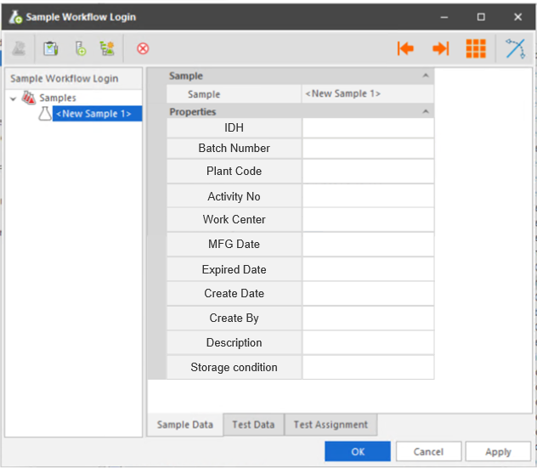
Properties in entity template clarification in LIMS:
No. | Properties | Type | Prompt Type | Description
1 | IDH | Numeric | Mandatory | Links to MLP table
2 | Batch | Text | Mandatory | Batch id
3 | Plant code | Text | Optional | Links to Plant table
4 | Activity No | Numeric | Optional | Activity number
5 | Storage Condition | Text | Optional | Fetch from substance table
6 | Work Center | Text | Optional | Links to Work centre table
7 | Create Date | Date | Optional | Current date, modifiable.
8 | Create By | Operator | Optional | Current operator
9 | Description | Text | Optional
10 | Sample Type | Default | Hidden | IPQC；sample type workflow is automatically assigned by lims
11 | MFG Date | Date | Optional | Manufacture date
12 | Expired Date | Date | Optional | Expiration date

Entity template 3: for OQC workflow

Properties in entity template clarification in LIMS:
No. | Properties | Type | Prompt Type | Description
1 | IDH | Numeric | Mandatory | Links to MLP table
2 | Batch | Text | Mandatory | Batch id
3 | Plant code | Text | Optional | Links to Plant table
4 | Activity No | Numeric | Optional | Activity number
5 | Storage Condition | Text | Optional | Fetch from substance table
6 | Work Center | Text | Optional | Links to Work centre table
7 | Create Date | Date | Optional | Current date, modifiable.
8 | Create By | Operator | Optional | Current operator
9 | Description | Text | Optional | Description
10 | Sample Type | Default | Hidden | OQC；sample type workflow is automatically assigned by lims
11 | MFG Date | Date | Optional | Manufacture date
12 | Expired Date | Date | Optional | Expiration date

Entity template 4: for Non-Standard Testing workflow

Excel fields | Mapping in QCLAD application（Description）
Requestor's Department | Display
Name of Requestor | Display
Email Address | Display and to send back results back
Region | Display
Country | Display
Plant Name | Display
Plant code | Need to be mapped with SAP plant code
Work center | For those IDH with inspection plan QC LaD need to pull the work center from inspection plan, considering IDH & plant code. For "work center" entry by requestor, QC LaD shall only display those comment with no interface required.
IDH | Need to be mapped with SAP plant code to pull the right inspection plan
Material Description | Display
Batch Number | Display
Test | Display. QC operator will manually read the Test and map it with the right MIC of SAP inspection plan. QCLAD only needs to display the inspection plan
Use retain sample or not | To check whether retain sample is required in the non standard testing workflow
CCMS, SCMS, NCMR Number(If Any) | Display
Expected completion Date | Display

Ground Rules
1 | For material within SAP, system shall sync & pull the work center
2 | For material not in SAP, a dedicated QC LaD user shall select the work center from the task pool with the hint from manual entered work center(free text)
3 | For CCMS/NCMR/SCMS related test request, work center shall be pulled from SAP(workflow #9)
4 | For other test request, work center shall be pulled from SAP for those material have IDH, otherwise test request shall go to the task pool awaiting manual workcenter selection by supervisor/shift leader.(Workflow #11)
5 | Requestor can raise multiple test requests at once by simply add additional roles
Excel Sample template
Interaction Events:
Click the “Apply” button to complete sample login operation. The system will automatically create the samples and tests as shown below.
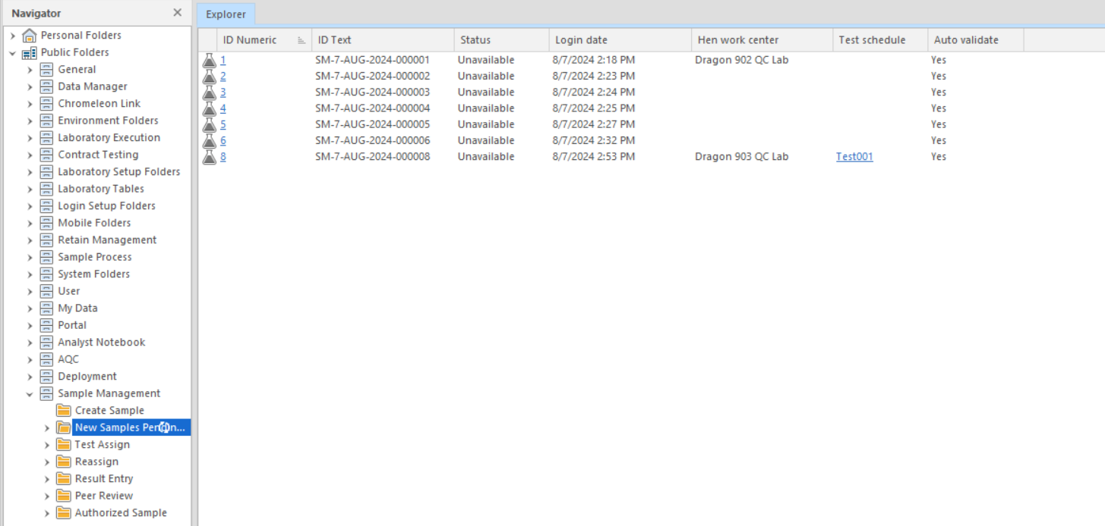
Situation clarification:
Sample Login three ways
- Automatically：LIMS create samples and tests automatically based on inspection lot by SAP interface. Inculding: IQC(standard RM)、IPQC 、OQC workflow. Sample type and material description will be automatically assigned by QCLad.
- Manually：User right click on specific workflow, click ‘run workflow’ RMB button and enter mandatory properties to create samples and tests. For example: temporarily testing.
- Special: For Non-Standard entity template, requestor needs to fill specific excel table in shared disk pathway regarding user requirements. LIMS will create samples without test items based on excel items. Inculding: Non-Standard testing workflow. Sample type and material description will be automatically assigned by QCLad.

Sample receiving

Business Scenarios
QCLad allows you to perform certain processing actions with a barcode scanner. Multiple samples can be scanned sequentially to complete an action, thereby multiple samples can be received at the same time by scanning label with MES barcode, and then user can print LIMS label within QCLad manually.

RTM Mapping
URS Ref. | Requirement | Type
4.1.1.3.2 | System shall be able to scan the Labels from MES system and fetch unique ID. | Customisation
4.1.1.3.4 | System shall allow user to print QCLaD Labels if the Plant doesn’t use MES system. | Standard
4.1.1.4.1 | System shall be able to retrive the sample receive date and time. | Standard
4.1.1.16.1 | System shall be able to scan barcode or QRCode and match barcode or QRCode sample in QCLAD system. | Customisation
4.1.1.18.1 | Sytem shall be able to allow entry / modification of attribute data at point of single or multiple sample receipt using configurable templates. | Configuration
4.1.1.18.2 | System shall be able to receive sample by scanning MES label | Customisation
4.1.1.18.3 | System shall be able to create labels for sample scan receiving for non MES samples. | Configuration

Function Design
Requirements Description：
Users can receive samples with scaning the Labels from MES system and entry/modify some modifiable fields while receiving sample. After completing receiving sample, user can print sample label within QCLad. (Based on RTM as above)
Design Overviews：
- Table change
Add new fields in sample table
i: hen_mes_id, text
ii: hen_received date, date
ii: hen_received by, operator
- Barcode Process Layout
Modify Columns of Sample Receive Barcode Layout:
i: hen_mesid
ii: hen_idh
iii: batch number
iv: hen_workcenter
v: idtext
vi: hen_received date
vii: hen_received by
- Folders and mater menu
Maintain menu in new sample pending receiving folder.
Add Test assign folder.
Add Samples in Testing folder.
- Functional logic
While the sample is received, the tests automatically created based on test schedule and automatically record the current server time and operator（in folder and dashboard, these time will displayed by client time zone）：
i: The sample status update as “Available”
ii: The operator is recorded as “received by”
iii: The current date is recorded as “received date”
iv: The tests status update as “Available”
v: The tests created exist in Test assign folder.
MES Labels can be scanned using receive sample interface of master menu 31026 in sample pending receiving folder and match corresponding fields.

Detail action description for workflow：
- For workflow IQC (Standard RM)：
  - Sample receiving by scanning MES labels.
- For workflow IPQC(without MES):
  - Sample receiving by manually click “Receive Sample” menu.
- For workflow OQC：
  - Sample receiving by manually click “Receive Sample” menu.
- For workflow Non-Standard Testing：
  - Sample receiving by manually click “Receive Sample” menu.

Function Entrance：
Sample Management Cabinet à New sample pending receiving FolderàRight click menu “Receive Sample”, then will pop up receive sample window as shown here.
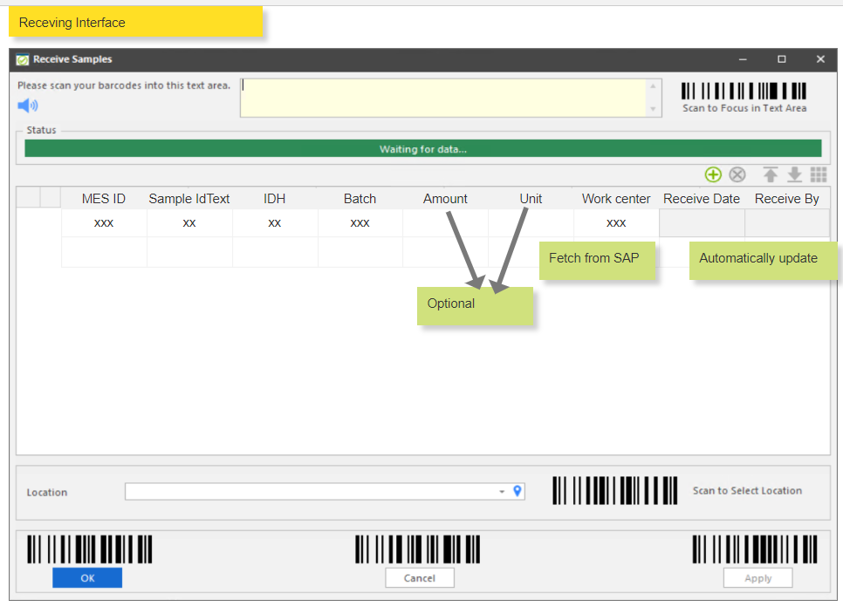
Sample receiving can also be operated by scanning MES labels, clicking "Receive Sample" menu in the menu bar above SampleManager, the sample receiving interface can also be popped up;
Users can scan the MES label in this interface, the system will automatically retrieve the unique sample displayed in the interface, you can scan more than once;
MES tag format: { Plant; material; batch; JIT or not; MES Sample ID; sampling date; sampling time; inspection type }
Example:
{'0759';'2870306';'45';'NOT';'0000116885';'2024-06-11';'04:11:10 PM'; 'IQC'}
{'0759';'2870306';'45';'JIT';'0000116885';'2024-06-11';'04:11:10 PM'; 'IQC'}
The system can retrieve the unique sample by scanning out the Plant, material, batch, inspection type and JIT or not, MES Sample ID, sampling date (including sampling date and sampling time) is automatically written into the sample and displayed in the interface;

Interaction Events:
- Receiving sample
Click the “Apply” button to complete sample receive operation.
The system will automatically close the window and create the tests in Test assign folder as shown here.
And the sample status will change to “Available” and will not shown in New sample pending receiving Folder anymore.
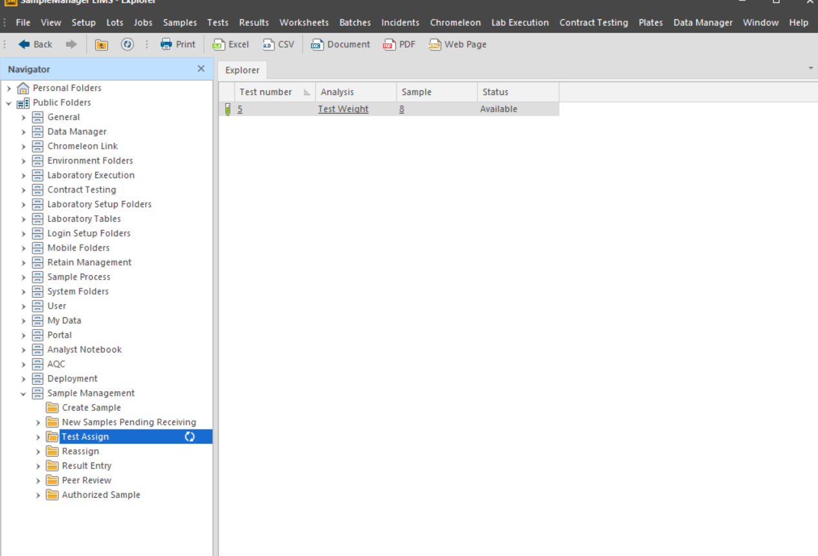
Note: The columns on the Explorer can be configured according to the display needs.

- Print sample label in QCLad
In samples in testing folder, user can select specific sample and then right click the “Print Label by Template” button to execute print sample label operation.
QCLad supports 2 way of label printing:
- Local printer printing label: will use client computer’s printer
- Network printing label: will use the printer installed on the lab server. Only within this way QCLad can print label automatically when sample is received.
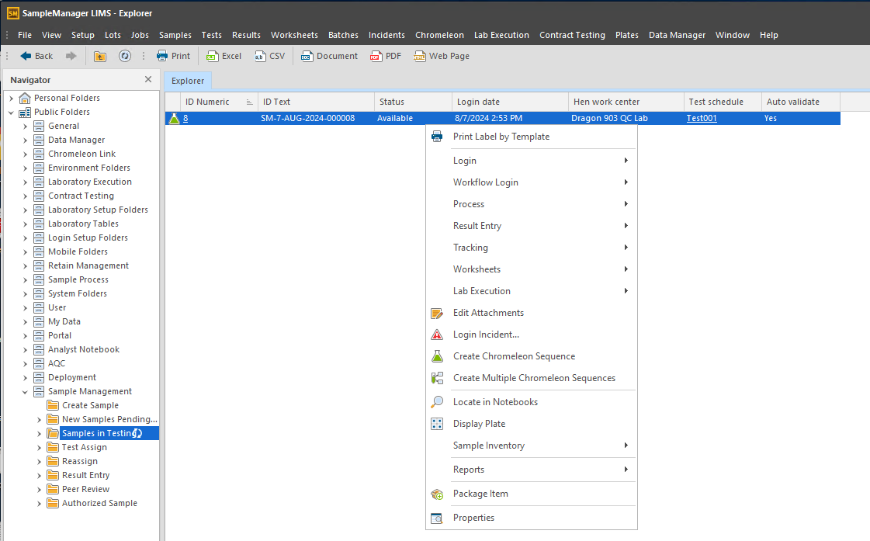
The system will automatically pop up the window and print as shown here. Network printing will not use this window

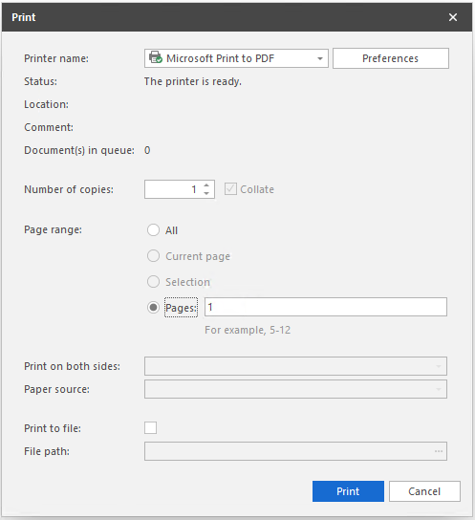
Note: label template prototype example as shown below:
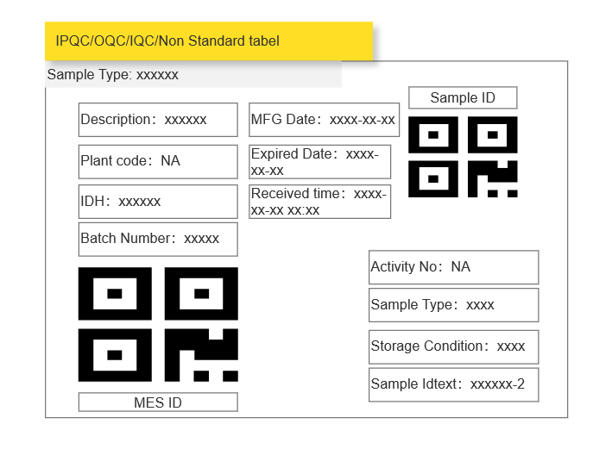
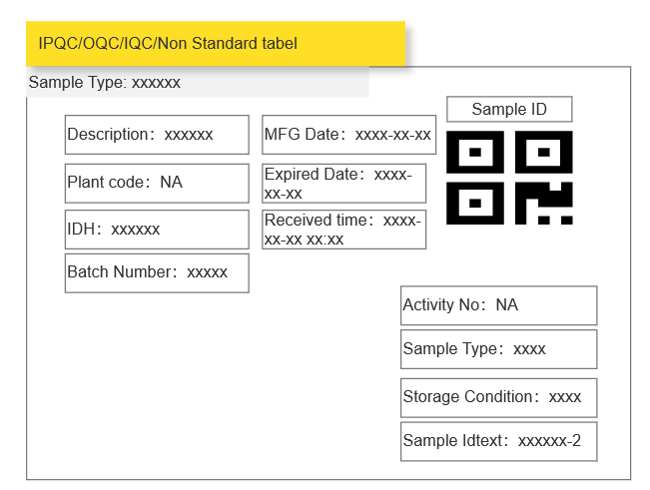
Description in detail:
Sample type | depends on the defined workflow | IQC\IPQC\OQC\NSQC
Sample ID | Generate from the QCLad
MES ID | fetch from the MES Label
Plant code | Fetch from the SAP
IDH | Fetch from the SAP
Batch Number | Fetch from the SAP
MFG Date | Fetch from the SAP
Expired Date | Fetch from the SAP
Received Date | Generate from the QCLad
Activity No | Fetch from the SAP
Storage Condition | From QCLad master data. | User can manual enter in IDH master data if needed.
Sample Idtext | Generate from the QCLad
Description | Fetch from the SAP | IDH description

Tests Preparation

Business Scenarios
Some analysis requires preparation of the specimen prior to performing the test. Users can specify the pre-test preparation process required for a particular analysis.

RTM Mapping
URS Ref. | Requirement | Type
4.2.1.1.1 | System shall be able to have option for a sample preparation which may be required for some analysis. | Standard
4.2.1.1.2 | System shall be able to assign preparation to an operator. | Customisation

Function Design
Requirements Description：
Many laboratory processes entail some form of preparation, for example filtering samples that contain particles or diluting concentrated samples. These can be important steps in analytical terms and so must be handled by SampleManager. Preparations are static data items that can control the handling of samples and tests. Preparations linked to samples and / or tests can affect the status values of both. Preparations are entered into the system via a typical Data Entry screen. The Wait for Preparation field can be set to Yes or No. If set to Yes then the related sample or tests status becomes W. When set to Yes then a Sample or Test will require positive action to complete the preparation and progress through the system can only take place after this positive action has been taken. Samples and Tests with Preparations assigned can be handled in bulk through the relevant Preparation Worksheet. Preparations may be found in the Environment Folders / Preparations folder.
Design Overviews：
- Table change
Add new fields in test table, to record preparation start date, target date and complete date.
Add new fields in test table, to record prepartion assign person.
Add new fields in test table, to record prepartion start person and preparation complete person.
- Workflow
Add nodes in test lifecycle:
- Start preparation: If the test has preparation method, then mark the test is in preparation status, set start date and start person. Automatically calculate the target date based on analysis static data.
- Complete preparation: if time now is larger than target date, mark the test is completed preparation. Allow the test to continue further process.
- Folders and Cabinets
Multiple folders will be added into sample management cabinet for usability:
- Tests waiting preparation: tests that has preparation step and its sample has been received.
- Test in preparation : tests are in preparation step currently.
Interaction Events:
Four workflows in Phase A are all adapt to this operation, therefore will not description in detail here.
- Static Data maintenance
Maintain and add preparation methods in certain analysis.
Test preparation on mic level. QCLad can distinguish samples which are in progress or not started. Display hen_status for user understanding in sample by adding new field in structure of QCLad.
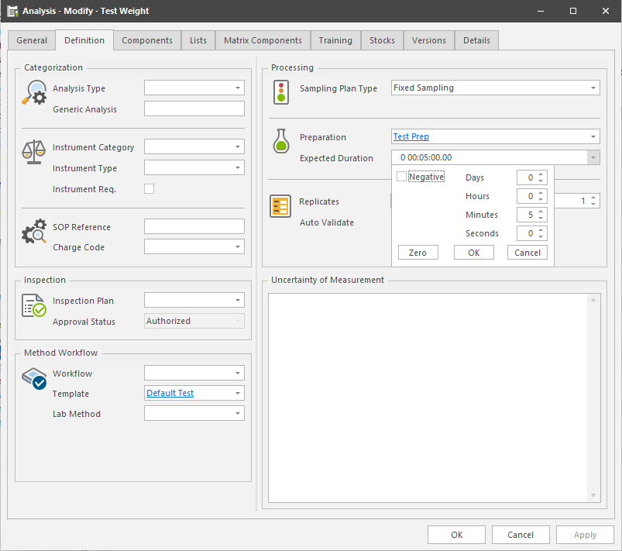
- Preparations
When a new sample that has test need to be prepared get received in lab, the certain test will enter awaiting preparation status in tests waiting preparation folder. Test will enter waiting preparation folder. Sample or tests can appear in multiple folders. User can start prepartion by RMB button ‘start preparation’. system will calculate the target completation time based on the analysis setup.
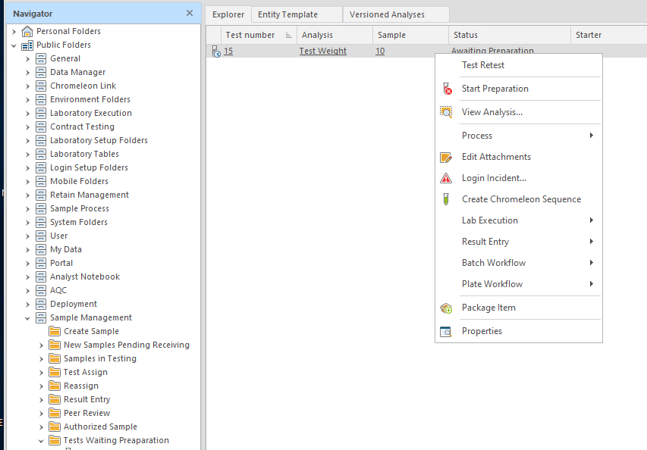

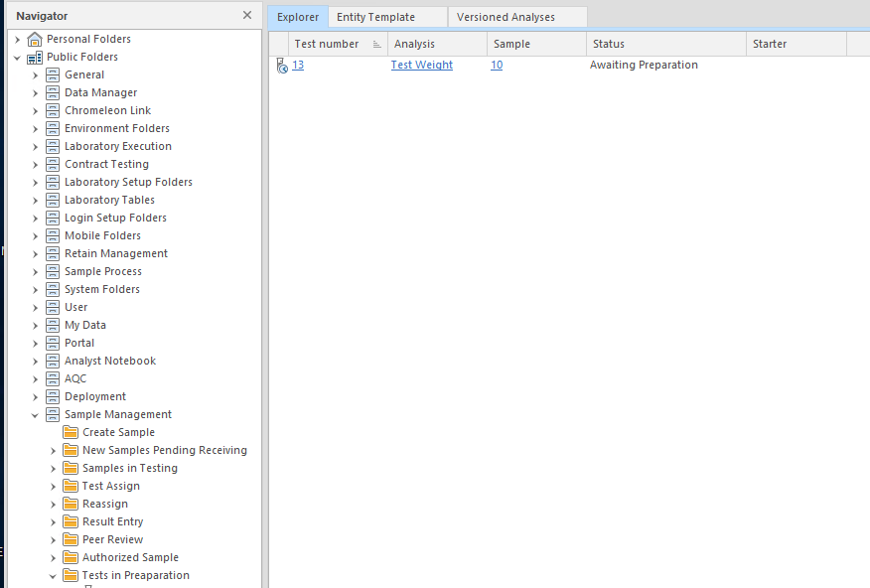
After user click start preparation, User can complete the preparation only when time is arrived. System will not allow user to enter results without complete preparation.
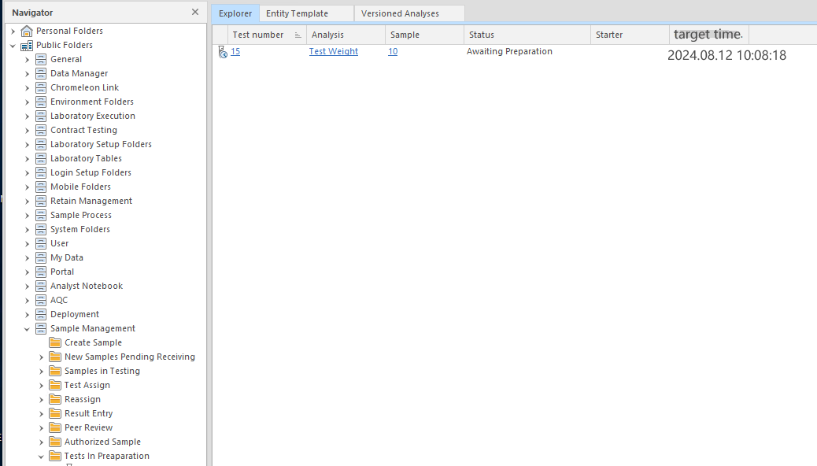
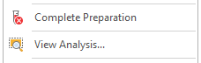
After the test is completed preparation, it can contine with further process.
Function Entrance：
Sample Management Cabinet à Tests waiting preparation FolderàSelect single or multiple tests and right click menu “Claim test Preparation”, then the test items will disappear immediately under Test Assign folder and shown in Result entry folder.

Sample Management Cabinet à Tests waiting preparation FolderàSelect single or multiple tests and right click menu “Tests Preparation Assign”, then will pop up window as shown here and user can select specific operator to execute the test.
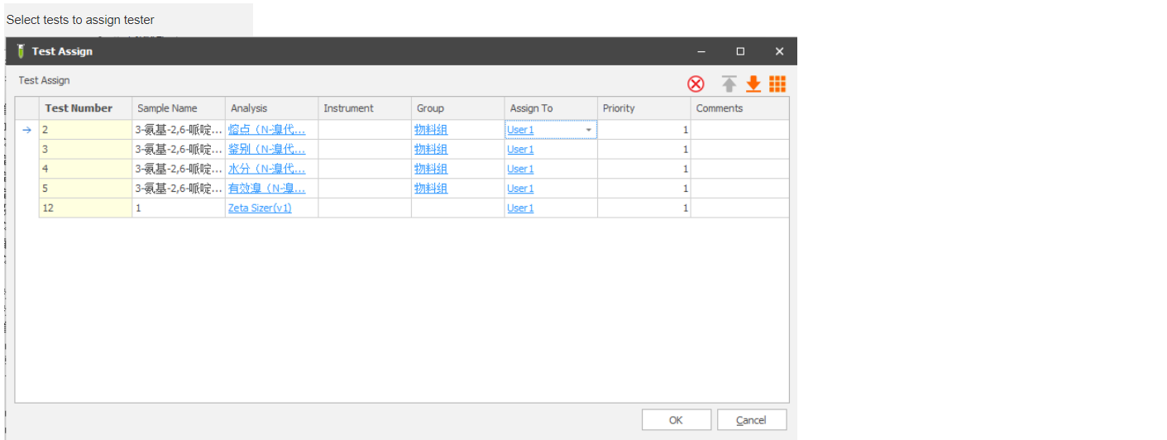
The people filtering filters are as follows：
Manual assign- selecting operator Filters:
1. lab(work center).
2. On-duty personnel (shift management).
User can assign test operator by multi select tests.

Tests Assign

Business Scenarios
When sample is received to lab, test items need to be assigned to lab operators so that lab operators can view their task list and start their own work. This assignment can be done automatically based on fixed rules or by manually assign. The assigned tests can also be reassigned to others.

RTM Mapping
URS Ref. | Requirement | Type
4.1.2.1.1 | System shall be able to assign tests to an operator manually or automatically. | Customisation
4.1.2.1.3 | System shall support to stop or modify auto assign task. | Customisation
4.2.1.1.6 | System shall be able to have standard time defined for each test assignment. This shall come from the master data to LIMS. | Configuration
4.2.1.1.16 | System shall be able to assign samples manually. | Customisation
4.2.1.8.1 | System shall allow user maintain master data for shift schedule by week. Number of shift and shift hour of each shift shall be configurable in the master data at plant level. | Customisation
4.2.1.9.3 | System shall allow user to rearrange task manually. | Configuration

Function Design
Requirements Description：
Users can manually assign tests to an operator or claim tests by themselves. And system support assign tests automatically based on shift rule defined in QCLad.
Design Overviews：
- Table change
Add new fields in test table, to record testing assign person.
- Folders and mater menu
Add Samples in Testing folder.
Add Reassign folder
- Functional logic
While the test is assigned to an operator completely：
i: The starter of test update as assigned user.
ii: The tests automatically existed in Reassign folder

Function Entrance：
Sample Management Cabinet à Test Assign FolderàSelect single or multiple tests and right click menu “Claim test”, then the test items will disappear immediately under Test Assign folder and shown in Result entry folder.
Sample Management Cabinet à Test Assign FolderàSelect single or multiple tests and right click menu “Test Assign”, then will pop up window as shown here and user can select specific operator to execute the test.

The people filtering filters are as follows：
Manual assign- selecting operator Filters:
1. lab(work center).
2. On-duty personnel (shift management).
User can assign test operator by multi select tests.

Interaction Events:
Note: Four workflows in Phase A are all adapt to this operation, therefore will not description in detail here.
- Assign tests
System has three ways to assign tests to technician.
- User can assign tests to an operator then the technician can entry results for tests.
- User can claim tests by themselves and then they can entry results for tests.
- System can automatically assign tests to an operator based on shift rule.
- Reassign tests
System support reassign tests for some situations, when tester needs to be changed, privileged user can move to Reassign folder to reassign test to another operator.

Result Entry

Business Scenarios
Generally, an analysis must have at least one component defined. A component is an item for which a ‘result’ * will be expected. System support entry results by single or multiple samples or by single or multiple tests.
Some details will be mandatory (*) for certain data/result types.
Numeric | Min/Max values set the range for acceptable or reasonable results. For example, pH values must lie between 1 and 14.
Boolean | True Word / False Word values will show the result options when a result passes / fails a Boolean test. ‘True’ & ‘False’ are the defaults.
Character | Allowed Chars values show the allowable characters when a result is based on a letter or symbol. ‘A-Z’ are the defaults
Textual | Free text entry.
Option* | Option shows the ID of a Phrase List that has been created as static data. The list has the options that can be selected at result entry.
Calculated* (K) | Calculation or Formula value shows the ID of a Calculation or the Formula definition that has been created as static data.

RTM Mapping
URS Ref. | Requirement | Type
4.1.1.19.1 | The system shall provide functionality to allow entry of any irregularities recorded sample according to laboratory business rules. | Standard
4.1.1.19.2 | The system shall provide functionality to allow entry of any routine sample according to laboratory business rules. | Configuration
4.1.2.3.1 | System shall be able to display all results data to the sample. | Standard
4.1.2.4.1 | System shall be able to calculate results based on reported or recorded data which from instruments. | Configuration
4.1.2.5.1 | System shall be able to record all data in whole testing process, including raw data captured from instrument, entry data, data calculated by formular, reported data, data which push to SAP. | Standard
4.1.2.5.2 | System shall be able to mark final results against specification limits and flag failures. | Configuration
4.1.2.7.1 | System shall be able to support results entry for multiple tests performed on a single sample. | Standard
4.1.2.8.1 | System shall be able to support results entry for an individual test on a single sample. | Standard
4.1.29.1 | System shall be able to support results entry for single or multiple tests performed on multiple samples. | Standard
4.1.2.10.1 | System shall be able to verify entered results data (e.g., pH, sample color, specific gravity) against specification limits. | Standard
4.1.2.11.1 | System shall be able to prevent the acceptance of partial or incomplete data entry for results and active samples. | Configuration
4.1.2.13.1 | System shall be able to support multipe analysis type, including numeric, text, characters, calculated, file, Boolean and optional. | Standard
4.1.2.14.1 | System shall be able to entry result data manually. | Standard
4.1.2.15.1 | System shall support attachment format: Xps, txt, resx, repx, xml, rtf, jpg, jpeg, img, svg, doc, pdf, ico, png, lbl, resources, caf, csv, log, msg, smpkg. | Standard
4.1.2.21.1 | System shall be able to record multiple users against a test or result. | Standard

Function Design
Requirements Description：
Users can record results entry for single or multiple tests performed on multiple samples. Users can record multiple result type and can upload attachments. And system can unlimited user to enter irregularities or partial or incomplete results and mark result against MLP.
Design Overviews：
- Folders and mater menu
Add Result entry folder.
Add Result review folder.
- Functional logic
While all the results of the sample is saved completely:
i: the samples status automatically update as “ completed” .
ii: the tests status automatically update as “ completed” .
While partial results of the test is saved:
i: the test status automatically update as “ In Progress”

Function Entrance：
Sample Management Cabinet à Result entry FolderàSelect single or multiple tests and right click menu “Result Entry” àSelect menu “Entry by test list” as shown here.

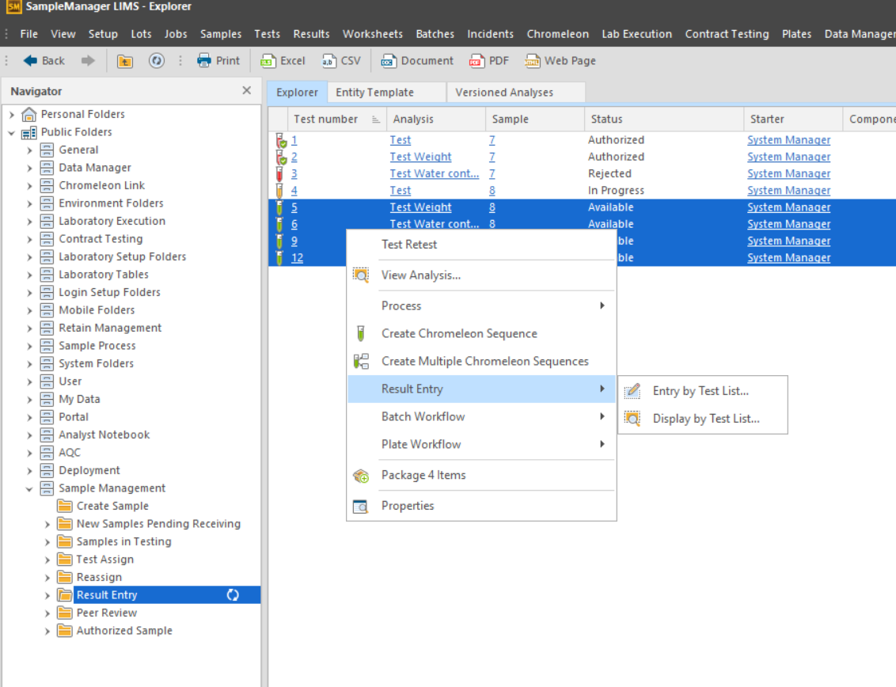
And then will pop up result entry window as shown below.

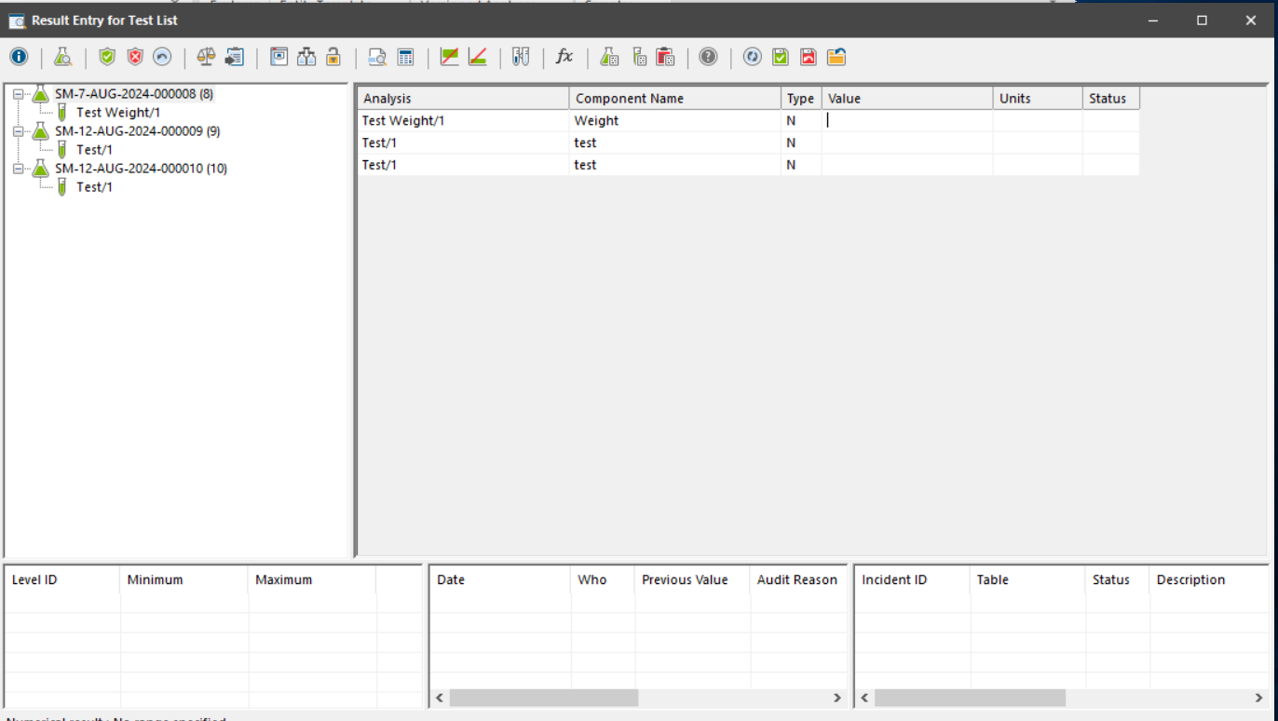
Under navigation barà select sampleà Select “Result Entry” àSelect menu “Open Samples” as shown here. Select single or multiple samples RMB “Entry by sample(s)”.
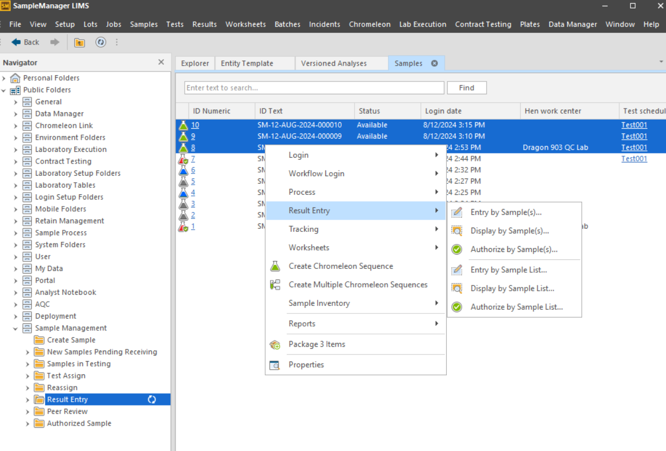
And then will open result entry window as shown here.
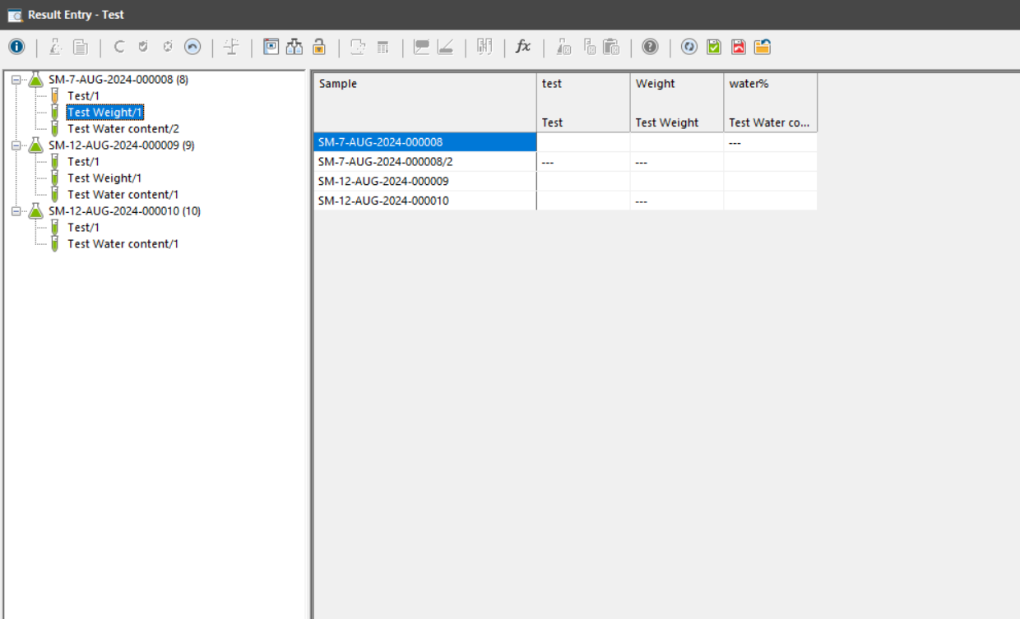
Interaction Events:
- Four workflows in Phase A are all adapt to this operation, therefore will not description in detail here.Result entry two ways
By Sample: the result entry screen is tabular and results are entered into cells by analysis and component.
By Test: the result entry screen is tabular and results are entered into cells by test and component.
- The Results Entry screen has two formats
Depending on the menu option chosen. The operations of both formats are the same. Results are entered into the value / component column as shown. The Status column displays the result status after entry of a result.
- Modify results
Results can be modified at this screen. The user will be asked to confirm any modifications. It is not necessary to enter all of the results in one session. Results can be entered and modified at any time (E or M). To save results to the database click the save button.
Copy results
- Add ad-hoc results
Not all tests are routine, for Non-Standard testing, user usually needs to add some temporary tests, so user can use add hoc results function to meet their requirements.

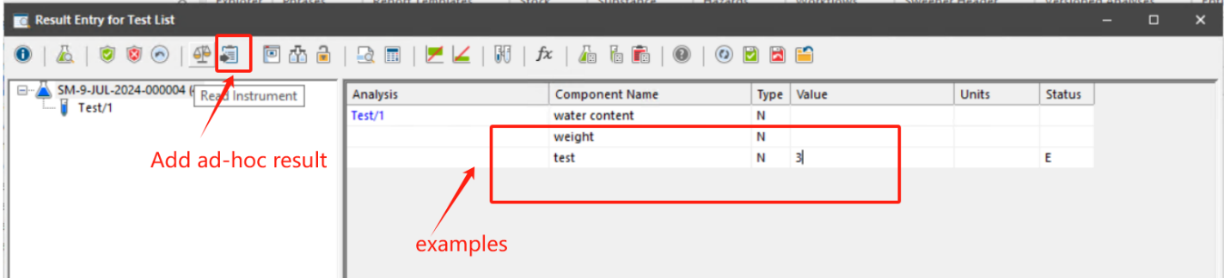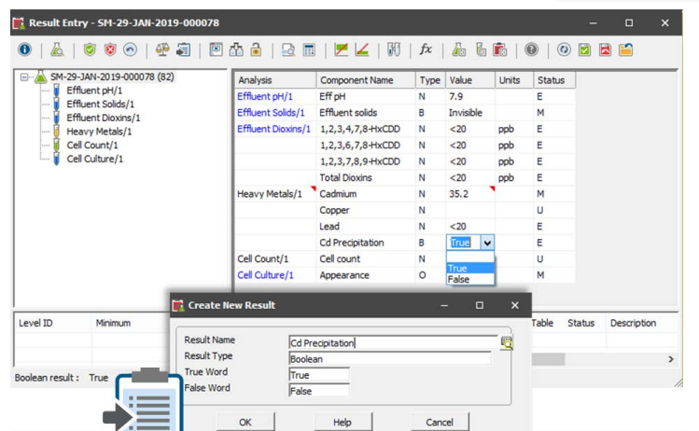
Sometimes you will need to add a result to a sample that is not defined in the analysis that creates the test. This is called an Ad-Hoc result. Consider a sample that arrives in the laboratory, and it does not conform to the normal situation. For example, the sample appears to have solid particles suspended in it and this is not usual as shown above. Enter (create) a result name and appropriate values into each field based on the result type selected.

Copy Result

Business Scenarios
For some OQC sample, based on requirements, system can support copy IPQC last phase sample results to OQC sample results, and then the OQC sample will not need to fill in results anymore manually.

RTM Mapping
NA

Function Design
Requirements Description：
The user manually selects the IPQC samples that need to be copied to the OQC, and the system will match the OQC samples with the same lot number as the SAP inspection lot for that IPQC and copy the results to the OQC samples and determine the results based on the specification;
Design Overviews：
- Folders and mater menu
Add Sample Authorized folder.
- Table change
Add new fields in Sample table to “phrase no” (text field) from SAP Inspection lot.
Add new fields in Sample table to “result from” (links to sample)

Function Entrance：
Sample Management Cabinet à Sample Authorized FolderàSelect single sample and right click menu “Copy Result To OQC”.
- Need to add a master menu “Copy Result”, which should be only visible to all IPQC sample.
Note：the time being, this menu should be visible to all the IPQC sample. Later on, if any further restriction is needed, can treat this as enhancement.
- After click on the “Copy Result” menu, system should query all the IPQC sample, regardless what status it is, whose inspection lot no is the sample with current sample. And then to further check the among all the queried samples if the “phase no” of current sample is the biggest one, if biggest one then seen as last phase, then system can proceed the next logic. If not, will prompt warning message and terminate the copy actions.
- The system will look for samples with an Inspection Type of OQC (Phrase no :0010) based on the SAP Inspection Lot number of the selected sample, and give a reminder if it does not exist or if more than one exists, and will not copy the results;
- The system compares the test items in the selected samples with the test items of the OQC samples found, and gives a reminder if there is a discrepancy, and does not copy the results;
- Instead, the full results (excluding the added Ad-Hoc results) are copied to the OQC sample and determine the results based on the specification;
- After the results are copied into the OQC sample, system also needs to copy the IPQC sample ID into the field “Result From” of the target OQC sample.

Test Retest/Resample

Business Scenarios
User need to retest a test item if there is any mistake or strange data. System need to create retest without lossing original test record.
User need to trigger resample if they need a new sample. Workshop will send a new sample and then lab will start to work on the new sample.

RTM Mapping
URS Ref. | Requirement | Type
4.1.2.22.1 | System shall be able to retest without loss of original data. | Configuration
4.1.2.23.1 | System shall be able to enforce entry of a justification if there is a retest/resample. | Configuration

Function Design
Requirements Description：
System allow user to retest a test item or trigger resample in QCLad.
If a test is triggered retest, a new same test will be created and itself will be rejected automatically.
If a sample is triggered resample , system will create a new sample and copy sample properties.
When retest or resample is triggered, system will ask a mandatory comment.
Design Overviews：
- Table changnchange
Add new fields in test table, to record retest date.
Add new fields in sample table, to record resample date and comment.
- Workflow
Add nodes in test lifecycle:
- Test Retest: create a new same test and reject the origin test automatically
Add nodes in sample lifecycle:
- Resample: create a new same sample. system will create a new sample and copy sample properties including IDH, test items, batch no to new sample. MES ID will automatically updated in new sample. After resample, user can select cancel original samples.
Detail description as below:

- Resample triggering process:

Case 1: before sample review (during inspection, or during sample review)-->just trigger resample to create another sample but not cancel original sample-- then need to process these two samples respectively on their own-- the result of both sample should be pushed to SAP.

Case 2: before sample review (during inspection, or during sample review)-->just trigger resample to create another sample but CANCEL original sample manually done in LIMS by user-- then need to process tnew sample—then push to sAP after reveiwe.

Case 3: after sample review, won’t allow resample action.

Case 4: sample amount is not enough for retain after sampel review. It has nothing to do with resmaple. Resample is the concept to ask for additional sample for further additional testing but not for retain.

In terms of the process to create the retain sample, whether munaylly or auto, will be discussed further on PPB.

- Folders and Cabinets
Multiple folders will be added into sample management cabinet for usability:
Resampled samples: list of samples that are resampled.
Interaction Events:
Four workflows in Phase A are all adapt to this operation, therefore will not description in detail here.
- Test retest
User can click ‘test retest’ RMB in result entry and peer review folders to trigger retest.
A new test will create and the original one will get rejected.
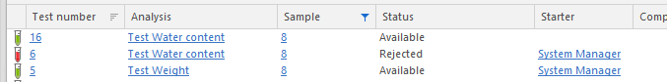
- Resample
User can click ‘Resample’ RMB in ‘samples in testing’ folder. A new sample will be created and it will be in pending receive folder waiting for receiving. The original sample will be stay in the batch. Origin sample will be marked as Is_resampled.

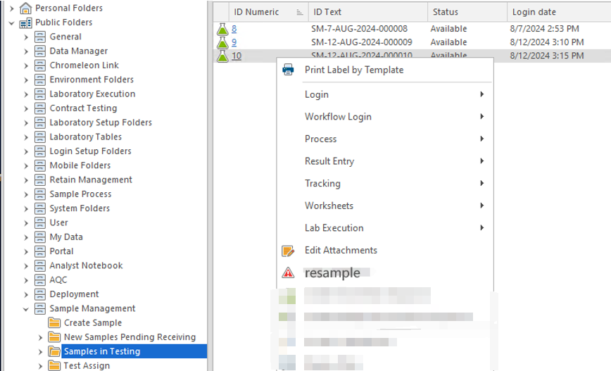

Result Review

Business Scenarios
While user complete the results entry, usually in order to release the samples need peer review to authorize results here.

RTM Mapping
URS Ref. | Requirement | Type
4.1.2.25.1 | System shall be able to enforce peer review by a different user at the material group level. | Configuration
4.1.2.25.2 | System shall be able to support peer review by configurable option. | Configuration
4.1.2.26.1 | System shall allow the peer review of results by Single sample, Multi test and Multi sample, single test where required. | Standard
4.1.2.27.1 | System shall prevent user from further modification on test data after peer review except authorized user and audit trail will be record. | Configuration
4.1.3.1.1 | System shall be able to approve individual results. | Standard
4.1.3.1.2 | System shall be able to support configure approve option within workflow. | Configuration
4.1.3.2.1 | System shall be able to approve single or multiple samples. | Standard
4.1.3.3.1 | System shall prevent user from further modification on test data after peer review. | Configuration
4.1.3.3.2 | System shall be able to return test to tester if result need modification . | Configuration
4.1.3.4.1 | System shall be able to configure system approval functionality at test level and sample level. | Configuration
4.1.3.5.1 | System shall be able to approval manually at test level and sample level. | Configuration
4.1.3.6.1 | System shall prevent the sample authorization with incomplete testing and alert defined users to the situation in folder. | Configuration
4.1.3.9.1 | System shall provide a way to check and indicate the results/samples waiting for approval. | Configuration

Function Design
Requirements Description：
Users can review and approve results for tests and samples.
Design Overviews：
- Folders
Add Authorized folder.
- Functional logic
While all the results of the sample is Authorized completely:
i: the samples status automatically update as “Authorized”
ii: the tests status automatically update as “Authorized” .

Function Entrance：
Sample Management Cabinet à Result review FolderàSelect single or multiple tests and right click menu “process” àSelect menu “Authorize” , then will open the authorize window as shown here.

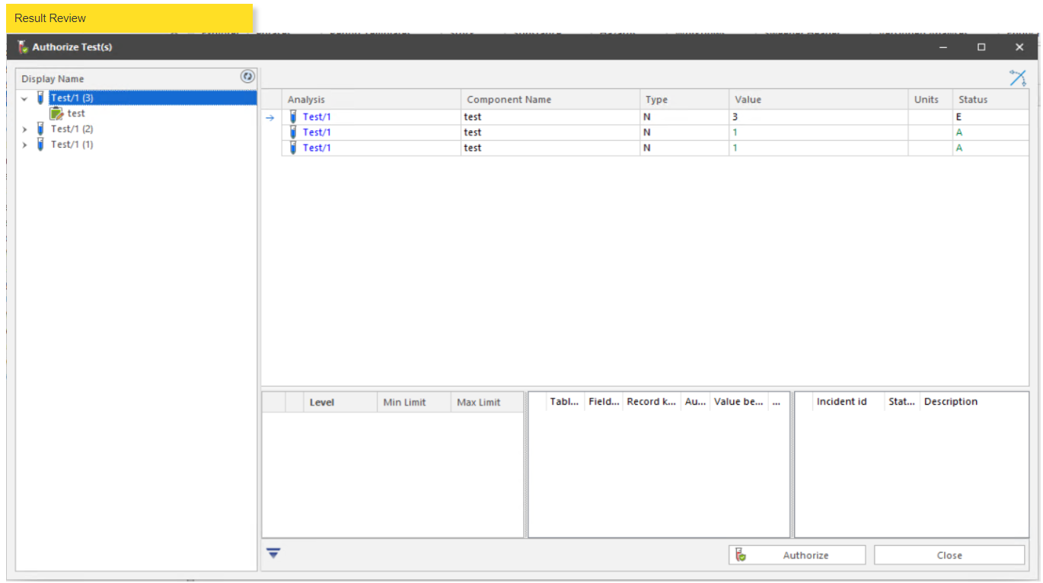

Interaction Events:
Four workflows in Phase A are all adapt to this operation, therefore will not description in detail here.
- Result review
Click the “Authorize” button to complete tests review operation.
The system will automatically close the window and tests status will automatically update as “Authorized”.
All the tests of the sample are authorized, the sample will shown in Authorized sample folder.

Certificate Generation

Business Scenarios
After testing result is reviewed and pushed to SAP, generally, testing report or COA will be generated there in SAP using existing report template.
However, it also supports to generate the test report directly in QCLAD when needed.
In a test report, it allows to include the sample information and testing results as designed in the report template; it also allows to include the results from multiple tests and across samples.

RTM Mapping
URS Ref. | Requirement | Type
4.1.4.10.1 | System shall support to generate single sample report, multiple sample report, COA report. | Configuration
4.1.4.3.1 | System must be able to report on the analyzed data at all levels (e.g., raw, recorded and reported analytical data). | Configuration
4.1.4.4.1 | System shall collate results from multiple tests for each sample. | Configuration
4.1.4.8.1 | System shall be able to generate analytical reports based on the data recorded in QCLAD like date time, QC operators details along with inspection. | Configuration

Function Design
IQC-Standard RM
After sample is reviewed and authorized, the sample status will be updated to Authorized, and will move to folder “Authorized Sample” folder in QCLAD.
User can right click on any samples from this folder and select “Create Certificate”, and needs to further select a certificate template to proceed the creation.
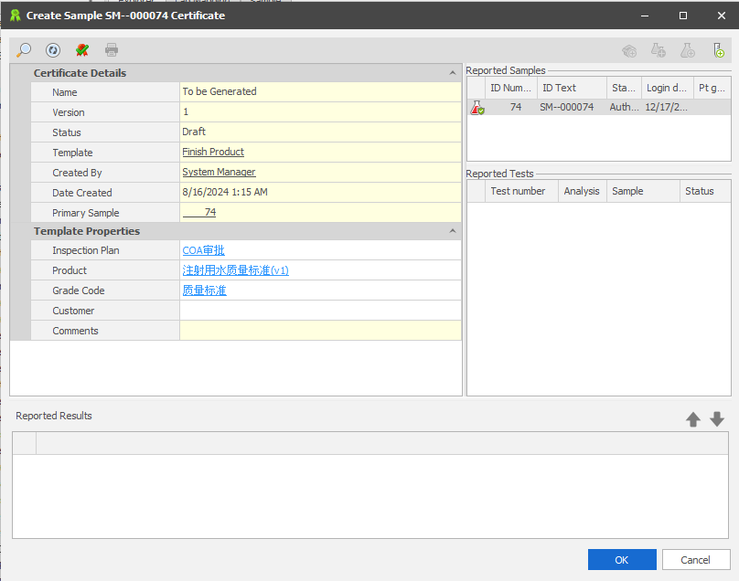
Note: in QCLAD a testing report or COA is referred as Certificate. And a certificate template is the master data which needs to be maintained and used before certificate creation.

in the creation form, user can
On the template properties section: sample information can be auto fetched and populated here as configured; and user can add in more information as needed. And all these information will be saved as attributes of current certificate and displayed in the certificate as designed accordingly.
On the reported sample/test section: user can add more sample/test into current certificate if allowed in certificate template configuration.
On Reported results section: once range of samples and tests are defined, the results will be displayed here along with their analysis name, result name, value, units, limits.
If everything is good, user can preview the certificate, then click on Apply/OK to create the certificate.

IPQC without MES
Can refer to point 1.
OQC without MES
Can refer to point 1.
Non-routine sample
Can refer to point 1.

Certificate Approval

Business Scenarios
After certificate is created, for different types of testing report, such as IPQC testing report, it requires not further approval; yet for OQC testing report, it needs review before approval.

RTM Mapping

URS Ref. | Requirement | Type
4.1.4.11.1 | System shall be able to route the output of reports to screen, printer, file (CSV, XML, PDF) or email. | Standard

Function Design
IQC-Standard RM
After certificate is created, according to the inspection plan (approval plan) configuration in certificate template, the certificate will be auto approved since no review is required. The certificate will be under “Authorized” status and parked under “Authorized Certificate” folder
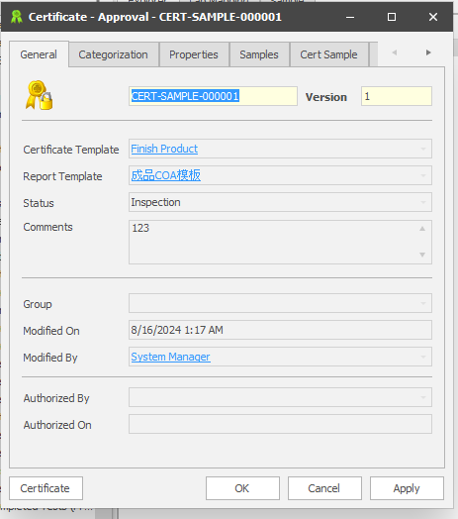
Click “Apply” will pop up window as shown below.
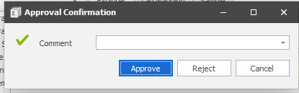
Right click on any certificate, user can view the display in pdf format. And user can further print out the pdf format certificate.

IPQC without MES
Refer to point 1.

OQC without MES
After certificate is created, according to the inspection plan (approval plan) configuration in certificate template, unlike IQC testing report, the certificate will be under “Inspection” status, meaning waiting to be reviewed by the person or role defined in the inspection plan.

And the subjected reviewer can right click on certificate and access to all the information related to this certificate. After review, user can click on OK and proceed approval decision and comment.
Non-Routine sample
Can refer to point 1.

Shift Management

Shift Management

Business scenarios
For project needs, the system needs to maintain the shift information of the plant personnel to serve the later use of the automatic task assignment function; Only need to maintain the on duty information , the user maintains the personnel shift information for a week or more at a time.

RTM Mapping

URS Ref. | Requirement | Type
4.2.1.8.1 | System shall allow user maintain master data for shift schedule by week. Number of shift and shift hour of each shift shall be configurable in the master data at plant level. | Customisation

Function Design
After comprehensively analysing the shift schedule requirements of personnel, a new shift schedule module needs to be added to the system to allow users to maintain the shift information of plant personnel in QCLAD on a weekly or longer cycle.

Base Master Data:
- Users need to maintain plant information, and in plant information, this module mainly maintains shift limits: the maximum number of consecutive working days and the maximum number of working hours in a week can be maintained.
Plant Table：
Field | Type | Description
Plant Code | text | should be unique
Description | text | Plant Description
Max working days | integer | the maximum number of consecutive working days
Max working hours | integer | the maximum number of working hours in a week can be maintained

- Users can maintain the shift type, the shift type table contains: Identity (should be unique, suggest to maintain manually as PlantID + “-” + Code), Code (such as M8, M12, D8), plant, Name (long day shift, long night shift, etc., the user to customize), start time (e.g. 8:30), end time (e.g. 20:30), RemoveFlag (whether to delete the identification);

Shift Type Table：
Field | Type | Description
Identity | text | should be unique, the user to customize, suggest to maintain manually as PlantID + “-” + Code.
Code | text | shift type code,such as M8, M12, D8.
Plant | text | Link Plant Table.
Name | text | shift type name, the user to customize, e.g. long day shift, long night shift, etc.
start time | interval | Working hours for shift types, e.g. 8:30.
end time | interval | Off work hours for shift type, e.g. 20:30.
RemoveFlag | boolean | whether to delete the identification.

  - The system supports for shift type data maintenance, and it can be added, removed, modified, displayed;

Main Master Data:
- The system should support that users can create a shift schedule for a group for one week (or two weeks, with a custom period) that contains: Id, Name, Description, Shift Period (start date, end date), Modifier, Modified Time, Plant, Enabled (indicates whether the scheduling is confirmed to be in effect), RemoveFlag (whether to delete the identification).
shift schedule table :
Field | Type | Description
Identity | text | should be unique, the user to customize.
Name | text | shift schedule name, the user to customize.
Shift Period Start date | Date | Shift Period Start date, e.g. 2024/08/05.
Shift Period End date | Date | Shift Period End date, e.g. 2024/08/09.
Modifier | text | Modifier for this shift schedule, Link Personnel Identity.
Modified Time | Date | Modified time for this shift schedule.
Plant | text | Link Plant Table.
Enabled | boolean | indicates whether the scheduling is confirmed to be in effect.
RemoveFlag | boolean | whether to delete the identification.

- A shift schedule can contain shift information for multiple people within the scheduling cycle, the same day can be maintained for more than one person more shift type of shift information.

  - The shift information contains: order number, personnel (Links Personnel Identity), shift type, shift start time (in datetime format), shift start time of the year, month, day, week, shift end time(in datetime format), the end of the shift time of the year, month, day, week, shift duration (unit: hour), description.
shift information table :
Field | Type | Description
Identity | text | shift schedule, Links shift schedule Identity.
order number | text | should be unique, System automatically generated.
personnel | text | shift worker, Links Personnel Identity
shift type | text | Links Shift Type Identity
shift start time | Date | start of work, e.g. 2024/08/05 8:30
shift start time of the year | integer | Year of the working hours, e.g. 2024
shift start time of month | integer | Month of the working hours, e.g. 8
shift start time of day | integer | Day of the working hours, e.g. 5
shift start time of week | integer | Week of the working hours, e.g. 1
shift end time | Date | end of work, e.g. 2024/08/05 20:30
shift end time of the year | integer | Year of the off work hours, e.g. 2024
shift end time of month | integer | Month of the off work hours, e.g. 8
shift end time of day | integer | Day of the off work hours, e.g. 5
shift end time of week | integer | Week of the off work hours, e.g. 1
planned hours | integer | planned hours (unit: hour), The hour difference between start of work and end of work.
actual hours | integer | The first time the scheduling information is created it is consistent with the planned hours field, which is automatically calculated by the system
description | text | shift information Description.

  - Because a scheduling can maintain shift information for a period of time such as one week or two weeks, the system supports displaying a calendar-formatted interface for the user to maintain shift information for each day of the cycle when maintaining shift information in the scheduling message;
For each day in the calendar, it displays all the shift information of the day, the shift start time (displaying the time is sufficient, not the date), the shift end time (displaying the time is sufficient, not the date), the ID of the personnel, and the shift type Code.

  - When you select a day in the calendar by right clicking on it, you need to have the ability to add, modify, and delete in the RMB
When a user maintains shift information and selects a date in the calendar to right-click to add or modify the shift information, after selecting the shift type, the start time and end time of the shift type will be automatically brought into the start time and end time of the shift, and the date of the start time and end time of the shift will be the current date selected in the calendar, and changes are allowed;

  - When the user maintains the shift information and clicks Save, the year, month, day and week fields of the shift start time will be written into the corresponding fields respectively; the year, month, day and week fields of the shift end time will be written into the corresponding fields respectively, and the user is not allowed to change them manually, and there is no need to display them on the interface; this is to facilitate the Excel export of the shift information later.

  - When a user maintains shift information and clicks Save, the planned hours and actual hours (in hours) is automatically calculated;
The planned hours calculation rule is: the number of hours obtained from the end time of the shift - the start time of the shift;
The actual hours calculation rule is: Consistent with the rules for calculating planned hours;

  - When the user maintains shift information and clicks Save, the system needs to verify whether the same person has more than one shift information on the same day, and if so, determine whether there is any time overlap in the information of more than one shift, and if there is any time overlap, then it will give a prompt and will not be submitted for saving;
Time overlap judgment logic: for example, Zhang San in 2024-7-19 8:30 to 2024-7-19 20:30 shift information type on shift, and Zhang San in 2024-7-19 13:30 to 2024-7-19 20:30 shift information type in the vacation, in the 2024-7-19 13:30 to 2024-7-19 20:30 the same If there are two trips in the same time period from 2024-7-19 13:30 to 2024-7-19 20:30, they are counted as overlapping;

  - When maintaining personnel scheduling, the number of working hours per natural week (Monday to Sunday) is restricted to be less than or equal to the maximum maximum number of working hours in a week in the plant, and the maximum number of consecutive working days is less than the maximum number of consecutive working days in the plant, and if the restriction is exceeded, a prompt will be given, and it will not be submitted for saving.
Calculation logic for continuous working days: query the number of entries of the shift information of the current personnel from the current day to the previous day, which are of the type of on-shift;

Calculation logic of working hours in a week: query the current personnel in the natural week of the day (for example, the day is Wednesday, then query the time from Monday to Wednesday) shift information table in the type of shift information in the shift in the class of the shift length of the cumulative addition;

  - The system supports adding, deleting, modifying and querying the Shift Scheduling information maintained by the user.

  - To create a new shift plan (essentially, is to create to planning for future time)
- Each shift will auto calculate the value of "current week", "planned hour", "actual hour" (by default, actual hour is the same as planned hour)based on the "Operator+ Day+ Shift Type"；be noted that each shift is breakdown by "Operator + Day".
- When apply to save, system will validate that, for each operator, if the total Actual hours of current week exceeded the maximum number of working hours in a week can be maintained (the variable configured on each plant). if yes, prompt warning and not allow saving.
- When apply to save, system will validate that, for each operator, if the consecutive work day of current week exceeded the maximum number of consecutive working days (the variable configured on each plant). if yes, prompt warning and not allow saving.

  - To update a created shift plan
- To add new shift for new operator or existing operator, will follow all the logic on case 2.9.
- To update the existing shift, one is allowed to modify the "Actual Hour" and key in "Comment".
- If the existing shift being updated is on current day or before current day, system will validate that, for each operator, if the total Actual hours of current week exceeded the 60 hours (the variable configured on each plant). if yes, prompt warning yet allow saving , given system should allow record what has happened.
- If the existing shift being updated is after current day, system will validate that, for each operator, if the total Actual hours of current week exceeded the maximum number of working hours in a week can be maintained (the variable configured on each plant). if yes, prompt warning and not allow saving.

  - To delete a created shift plan
Maintenance personnel with deletion permissions can delete the already created shift information, the system does not impose restrictions.

- The system should support the export of shift schedule data to Excel:
The user selects the time range and exports the personnel shift information: personnel ID, personnel Name, personnel work centre , shift type ID, date (date as table header), Displays the shift type and actual hours of the shift information.
Examples are shown below (ignore the background colour):
The screenshots are for reference only, the final design may differ from the screenshots in the document.
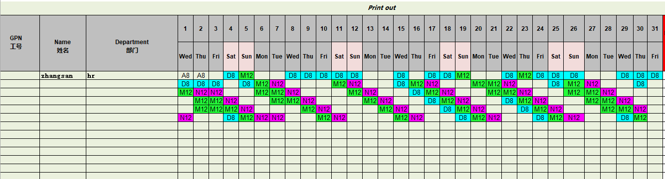

Master Data

Production Line

Business Scenarios
Currently in each Henkel’s plants, the semi-finished product and finished product are classified with a production line, for example MPT,TGS and PAS etc. however the raw material or packaging material, which are purchased from suppliers, is not yet categorized the same with production line.
And production line is not yet standardized across all plants with Henkel, the same products can be classified into different production lines in terms of naming even though their meanings are the same essentially.
For PPA, production line will be maintained by each plant respectively. In the future, if needed, Henkel will introduce another concept of Technology to standardize the naming of all the production lines within all the Henkel’ s plants.

Furthermore, production line information is not maintained in material master data in SAP; is maintained in MES only.

RTM Mapping

URS Ref. | Requirement | Type
N/A | N/A | N/A

Function Design

Production Line Maintenance
      - User should be able to manually maintain production line master data in QCLAD. And for each production line, user can maintain below information:
Table Field Name | Comment
Production Line | The name of the production line, part of the unique key.
Plant | The plant in which the production line is used, part of the unique key.
Description | Plain text field

      - User should be able to modify, display, and remove a work centre master data if given the privilege.

Relation between Production line and Material
For all the material master data synced from SAP down to QCLAD, on plant level, user should manually assign a production line to the material master.
- If semi-FP or FP material, just assign the adequate production line by selecting.
- If raw or packaging material, just select the generic production line given currently these type material is not classified with any production line.

Relation between Production Line and Sample
When an inspection lot is pushed from SAP to QCLAD, normally one sample will be created.
- if the material of that inspection lot is already linked with production line in QCLAD, the production line will be auto fetched and populated into the sample created for the inspection lot.
- If the material of that inspection lot is not yet linked with any production line in QCLAD, user can modify the sample and manually select the production line.

